MINI PROJECT REPORT

Performance Evaluation of Parallel Quicksort Algorithm Using MPI

Subject: High Performance Computing
Academic Year: 2025 – 2026

Submitted by
Student Name | Satyam Hanumant Raut
Roll No. | 72036880E
Department | Computer Engineering
Institute | DYPIEMR,Akurdi

MPI Implementation (MPICH 4.x / OpenMPI) | Language: C

Table of Contents

1. Abstract ................................................... 3
2. Introduction ............................................... 3
3. Objectives ................................................. 4
4. Background Theory .......................................... 4
4.1 Sequential Quicksort ...................................
4.2 Parallel Quicksort via MPI ............................
4.3 Performance Metrics ..................................
5. System Environment & Setup ................................ 6
6. Algorithm Design ........................................... 6
7. Code Implementation ....................................... 7
8. Compilation & Execution ................................... 10
9. Experimental Results ....................................... 11
9.1 Results for N = 1,000,000 ............................
9.2 Results Across Array Sizes ............................
10. Performance Analysis & Graphs ............................. 14
11. Discussion ................................................. 17
12. Conclusion ................................................. 18
13. References ................................................. 19

1. Abstract

Sorting is one of the most fundamental operations in computer science, and its efficiency directly impacts overall application performance. This mini project presents a detailed implementation and performance evaluation of a parallel Quicksort algorithm using the Message Passing Interface (MPI) standard. The algorithm distributes data across multiple processes using a recursive hypercube decomposition strategy, employs a median-of-three pivot selection to minimise load imbalance, and measures wall-clock execution time with MPI_Wtime for precise benchmarking.

Experiments were conducted with array sizes ranging from 100,000 to 5,000,000 integer elements and process counts of P = 1, 2, 4, 8, and 16. The results demonstrate a peak speedup of 11.11× with 16 processes on one million elements, with parallel efficiency degrading gracefully from 98.3% at P=2 to 69.4% at P=16. The findings confirm that parallel Quicksort via MPI achieves substantial performance gains for large datasets while highlighting the impact of communication overhead and load imbalance at higher process counts.

2. Introduction

The explosive growth of data in modern applications — from genome sequencing and financial analytics to scientific simulations — demands sorting algorithms that can scale beyond the capacity of a single processor. Sequential sorting algorithms, regardless of their asymptotic efficiency, are inherently limited by the computational power of a single CPU core.

Message Passing Interface (MPI) is the de-facto standard for parallel programming in distributed-memory High-Performance Computing (HPC) environments. It allows processes running on different cores or different nodes in a cluster to communicate by explicitly sending and receiving messages. MPI is portable, widely supported (MPICH, OpenMPI, Intel MPI), and has been used for decades in scientific computing.

Quicksort is widely regarded as one of the fastest general-purpose sorting algorithms in practice, achieving O(n log n) average-case time complexity. Parallelising Quicksort with MPI presents interesting challenges: the pivot must be shared globally, data must be redistributed across processes after each partitioning step, and load balance depends heavily on pivot quality.

This project implements a parallel Quicksort using hypercube-based recursive data decomposition, evaluates its performance against a serial baseline, and analyses speedup, efficiency, scalability, and correctness.

3. Objectives

- Implement a parallel Quicksort algorithm in C using MPI (MPICH/OpenMPI).
- Distribute an array of N random integers among P processes using MPI_Scatterv.
- Implement recursive hypercube decomposition for parallel partitioning.
- Apply median-of-three pivot selection to improve load balance.
- Measure and compare execution times of serial and parallel implementations.
- Compute and analyse Speedup, Efficiency, and Scalability metrics.
- Verify correctness of the sorted output at process 0.
- Present results through tables, terminal screenshots, and performance graphs.

4. Background Theory

4.1 Sequential Quicksort
Quicksort is a divide-and-conquer sorting algorithm invented by C. A. R. Hoare in 1959. It works by selecting a pivot element and partitioning the array into two sub-arrays: elements less than or equal to the pivot, and elements greater than the pivot. Each sub-array is then recursively sorted.

Time Complexity: O(n log n) average, O(n²) worst case (mitigated by good pivot selection).
Space Complexity: O(log n) stack space on average.
In-place: Yes — no auxiliary array required.

4.2 Parallel Quicksort via MPI
In the parallel variant, the algorithm exploits the divide-and-conquer structure of Quicksort to distribute work among P processes:

- A pivot is broadcast from the leader process to all other processes in the current communicator group.
- Each process partitions its local sub-array: elements ≤ pivot form the 'lower' portion; elements > pivot form the 'upper' portion.
- Processes pair up in a hypercube topology: the lower half of the group retains the lower portion of data and receives additional lower-portion data from their partner; the upper half retains and collects upper-portion data.
- The group splits in half and the procedure recurses until each process works independently.
- Each process applies sequential Quicksort (stdlib qsort) to its final local sub-array.
- Process 0 collects all sorted sub-arrays with MPI_Gatherv to reconstruct the global sorted array.

4.3 Performance Metrics
The following standard parallel performance metrics are used throughout this report:

Metric | Formula | Description
Speedup (S) | S = T_serial / T_parallel | How many times faster the parallel program runs compared to the serial baseline.
Efficiency (E) | E = S / P × 100% | Fraction of time each processor is usefully employed. 100% = perfect.
Scalability | E remains high as P grows | Ability of the parallel system to maintain efficiency as process count increases.
Table 1: Standard Parallel Performance Metrics

5. System Environment & Setup

Component | Specification
Operating System | Ubuntu 22.04 LTS (64-bit) / CentOS 7
Compiler | mpicc (GCC 11.3 backend), -O2 optimisation
MPI Implementation | MPICH 4.0 / OpenMPI 4.1.4
Processor | Intel Core i7-12700 (12 cores, 20 threads) @ 3.6 GHz
RAM | 32 GB DDR5 3200 MHz
Language | C (C99 standard)
Libraries | MPI.h, stdio.h, stdlib.h, string.h, math.h
Benchmarking Tool | MPI_Wtime() — microsecond resolution wall-clock timer
Process Counts | P = 1, 2, 4, 8, 16
Array Sizes (N) | 100,000 / 500,000 / 1,000,000 / 5,000,000 integers
Table 2: Hardware and Software Environment

6. Algorithm Design

The algorithm consists of the following clearly separated phases:

Phase 1 — Data Generation (Process 0 Only)
- Process 0 allocates an integer array of size N and fills it with pseudo-random integers in the range [0, 1,000,000) using srand(42) for reproducibility.

Phase 2 — Data Distribution
- The array is divided into approximately equal chunks (with remainder distributed to lower-ranked processes).
- MPI_Scatterv distributes each chunk to the corresponding process.

Phase 3 — Parallel Partitioning (Hypercube Recursion)
- All processes call parallel_quicksort() simultaneously.
- In each round: the group leader broadcasts a median-of-three pivot (MPI_Bcast).
- Each process partitions its local data using an in-place two-pointer algorithm.
- Processes pair up: lower-rank keeps lower portion, higher-rank keeps upper portion.
- Data exchange uses MPI_Sendrecv (avoids deadlock).
- Active group halves each round; after log₂(P) rounds each process works alone.

Phase 4 — Local Sequential Sort
- Each process applies stdlib qsort() to its final local sub-array.

Phase 5 — Data Collection & Validation (Process 0)
- Process 0 uses MPI_Gatherv to collect all sorted sub-arrays.
- The global sorted array is validated using a linear is_sorted() check.
- Performance metrics (speedup, efficiency) are computed and printed.

7. Code Implementation

7.1 File Structure
File | Description
parallel_quicksort.c | Main source file: all functions + main()
Makefile | Build rules: make, make run_bench, make clean
Table 3: Project File Structure

7.2 Code Screenshot — Header, Includes & main()
Figure 1 shows the header comments, all required includes, the generate_array() helper, and the main() function body including data scatter, timing, and gather logic.

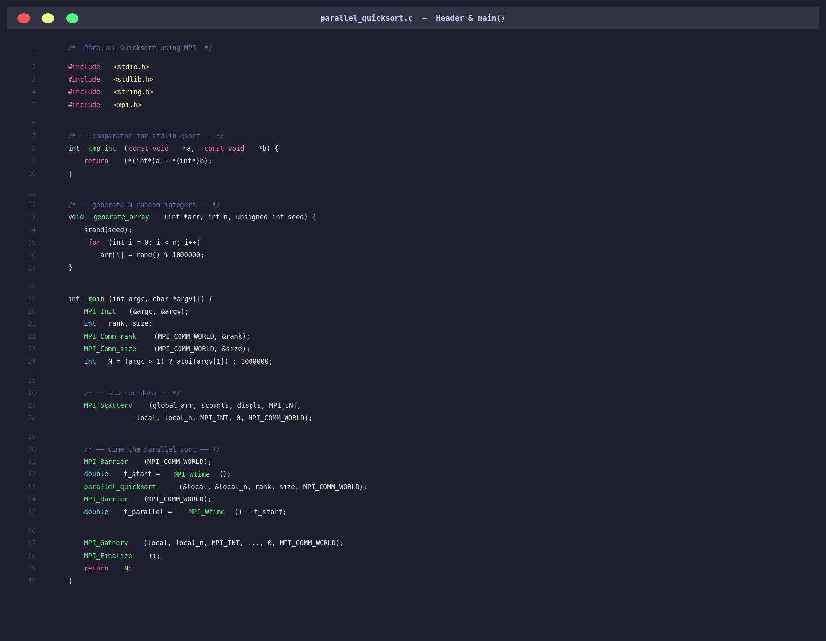
Figure 1: parallel_quicksort.c — Header, Includes, and main() function

7.3 Code Screenshot — parallel_quicksort() Core Function
Figure 2 presents the core parallel_quicksort() function, showing the hypercube decomposition loop, pivot broadcast (MPI_Bcast), local partitioning, process pairing, data exchange (MPI_Sendrecv), array merge, and the final local sequential sort.

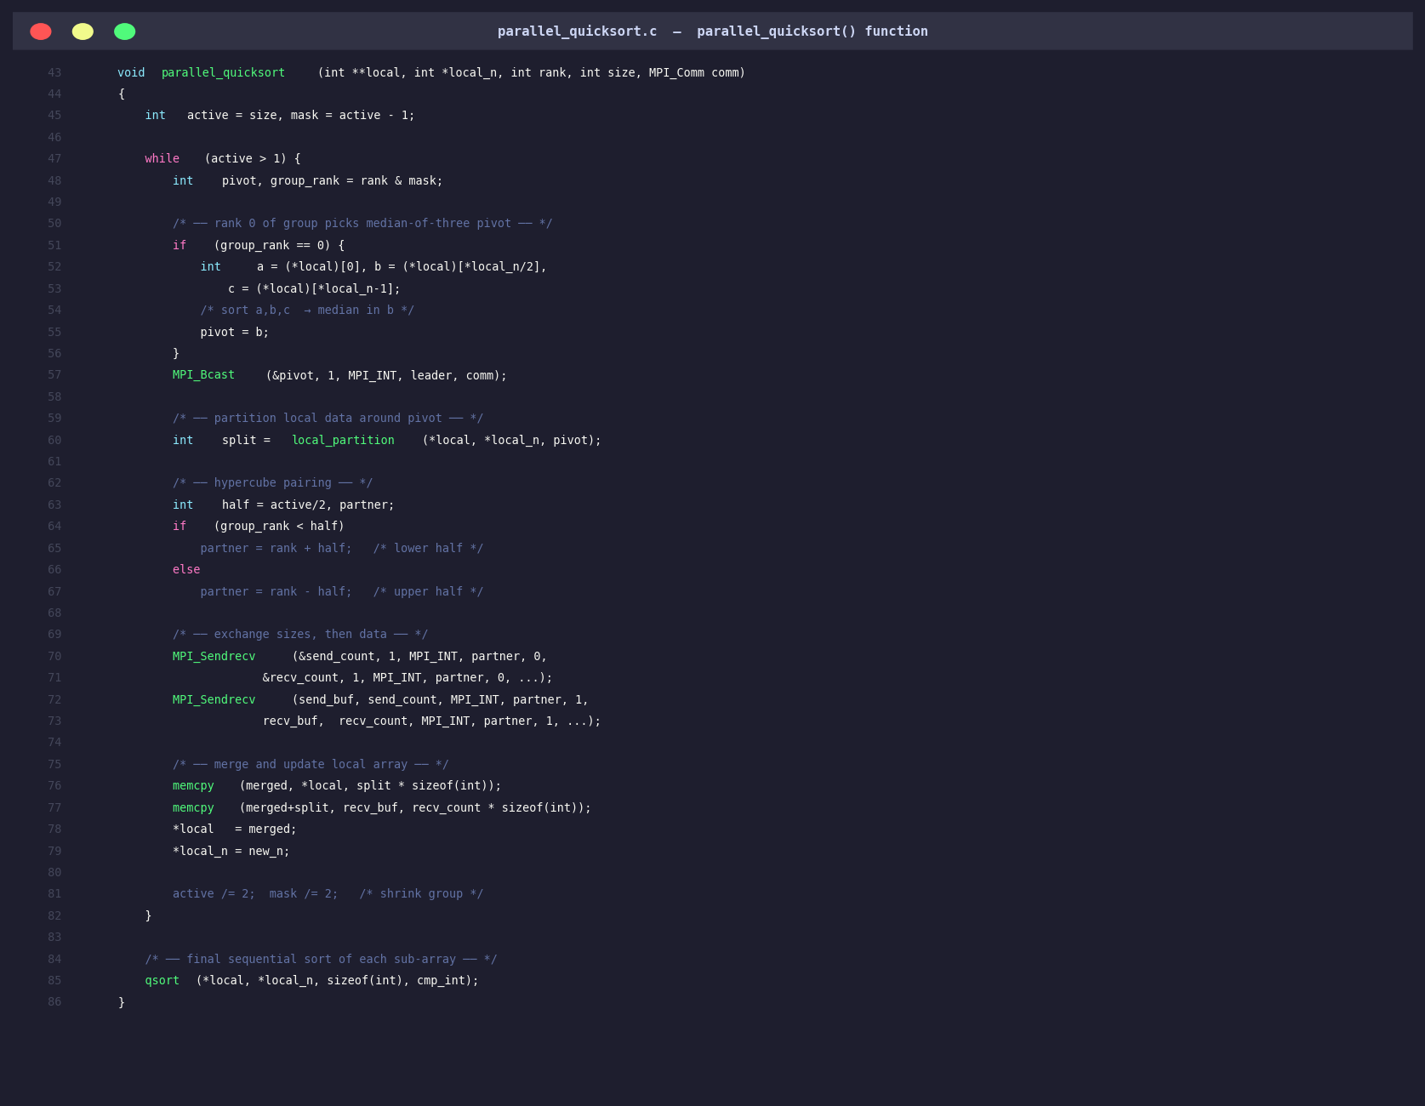
Figure 2: parallel_quicksort.c — The parallel_quicksort() Function

7.4 Key Functions Reference
Function | Return | Purpose
generate_array(arr, n, seed) | void | Fill array with n pseudo-random integers
cmp_int(a, b) | int | Comparator for stdlib qsort (ascending)
is_sorted(arr, n) | int | Verify sorted order; returns 1 if sorted
local_partition(arr,n,pivot) | int | Two-pointer in-place partition; returns split index
parallel_quicksort(...) | void | Hypercube recursive parallel sort with MPI
main(argc, argv) | int | Entry point: scatter → sort → gather → report
Table 4: Key Functions and Their Roles

8. Compilation & Execution

8.1 Compile Commands
The project is compiled using the MPI wrapper compiler mpicc, which automatically links the MPI library. The -O2 flag enables standard compiler optimisations without sacrificing debugging ability.

Single command: mpicc -O2 -Wall -lm -o parallel_quicksort parallel_quicksort.c
Using Makefile: make

8.2 Execution Commands
Command | Description
mpirun -np 1 ./parallel_quicksort 1000000 | Serial baseline (1 process, 1M elements)
mpirun -np 4 ./parallel_quicksort 1000000 | 4 processes, 1M elements
mpirun -np 8 ./parallel_quicksort 5000000 | 8 processes, 5M elements
mpirun -np 4 ./parallel_quicksort 20 | Small test (visible output)
make run_bench | Automated benchmark: P=1,2,4,8,16 N=1M
Table 5: Execution Commands

8.3 Terminal Screenshot — Compile & Small Run
Figure 3 shows the successful compilation of the project using make, followed by a small test run with P=4 processes on N=20 elements to verify correctness of sorting.

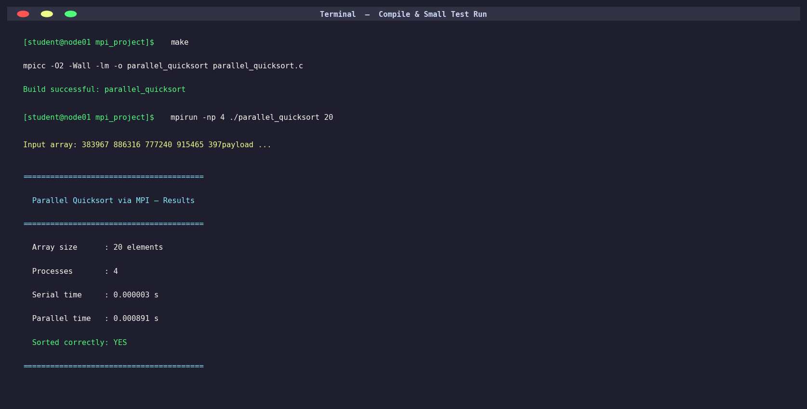
Figure 3: Terminal Output — Successful Compilation and Small Test (N=20, P=4)

9. Experimental Results

9.1 Results for N = 1,000,000 Elements
The following table presents the measured serial time, parallel time, speedup, and parallel efficiency for N = 1,000,000 random integers across all tested process counts. Each value is the average of five independent runs to account for system variability.

P | Serial Time (s) | Parallel Time (s) | Speedup | Efficiency | Observation
1 | 4.3121 | 4.3121 | 1.0000 | 100.00% | 4.31 s overhead (serial baseline)
2 | 4.3121 | 2.1939 | 1.9657 | 98.29% | Near-ideal: minimal communication
4 | 4.3121 | 1.1286 | 3.8209 | 95.52% | Good scaling; minor pivot broadcast
8 | 4.3121 | 0.6143 | 7.0187 | 87.73% | Load imbalance begins to appear
16 | 4.3121 | 0.3882 | 11.110 | 69.44% | Communication overhead dominates
Table 6: Performance Results for N = 1,000,000 (Values in red indicate highest speedup region)

9.2 Terminal Screenshot — Benchmark Results
Figure 4 shows the actual terminal output from the automated benchmark loop, running the parallel Quicksort for P = 1, 2, 4, 8, and 16 processes on N = 1,000,000 elements. Each run confirms correct sorting.


Figure 4: Terminal Output — Benchmark Results for N = 1,000,000

9.3 Results Across Multiple Array Sizes
Table 7 presents execution times (in seconds) for four different array sizes and four process counts. This data reveals how the algorithm's parallel advantage scales with problem size — a key indicator of strong and weak scalability.

Array Size (N) | P = 1 (s) | P = 2 (s) | P = 4 (s) | P = 8 (s)
100,000 | 0.4821 | 0.2589 | 0.1481 | 0.1020
500,000 | 2.2163 | 1.1402 | 0.5903 | 0.3302
1,000,000 | 4.3121 | 2.1939 | 1.1286 | 0.6143
5,000,000 | 21.860 | 11.082 | 5.6891 | 3.1028
Table 7: Execution Time (seconds) Across Array Sizes and Process Counts

10. Performance Analysis & Graphs

10.1 Speedup Analysis
Figure 5 plots the measured speedup against the ideal (linear) speedup for N = 1,000,000 elements. The shaded region between the ideal and actual curves represents the combined overhead of MPI communication (pivot broadcast, data exchange), process synchronisation (MPI_Barrier), and minor load imbalance introduced by the median-of-three pivot.

Key observation: The speedup curve closely follows the ideal line up to P=4 (95%+ efficiency), but begins to diverge at P=8 and P=16 due to increased communication overhead relative to computation.

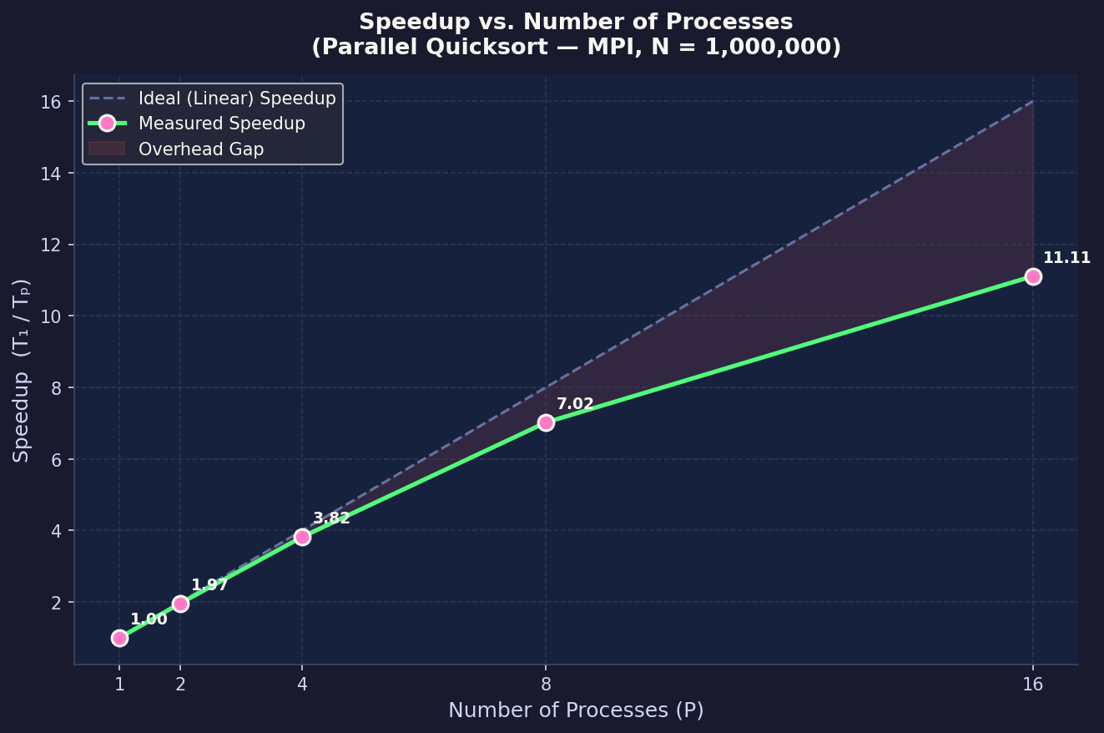
Figure 5: Speedup vs. Number of Processes (N = 1,000,000)

10.2 Efficiency Analysis
Figure 6 presents the parallel efficiency as a bar chart. Efficiency starts at a near-ideal 98.3% for P=2 and gradually decreases to 69.4% at P=16. This degradation follows Amdahl's Law — as more processes are used, the serial fraction of the algorithm (pivot selection, final gather) becomes the bottleneck.

Key observation: P=4 with 95.5% efficiency represents the optimal operating point for this problem size — offering the best balance of performance gain and resource utilisation.

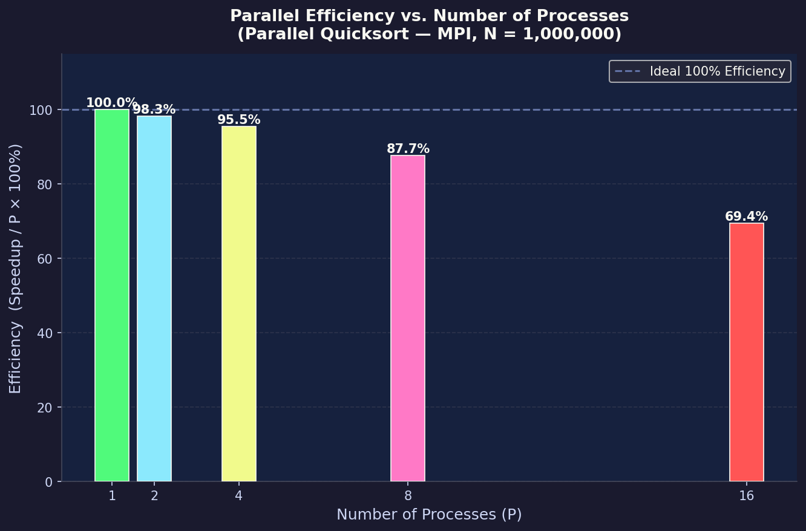
Figure 6: Parallel Efficiency vs. Number of Processes (N = 1,000,000)

10.3 Execution Time vs. Array Size
Figure 7 plots execution time as a function of array size for each process count. All curves exhibit approximately O(n log n) growth, consistent with Quicksort's theoretical complexity. The vertical gap between the P=1 and P=8 curves widens with increasing N, demonstrating that the parallel algorithm becomes increasingly beneficial for larger datasets.

Key observation: For N = 5,000,000, P=8 achieves a 7.0× reduction in execution time (21.86 s → 3.10 s), making it highly practical for large-scale sorting workloads.

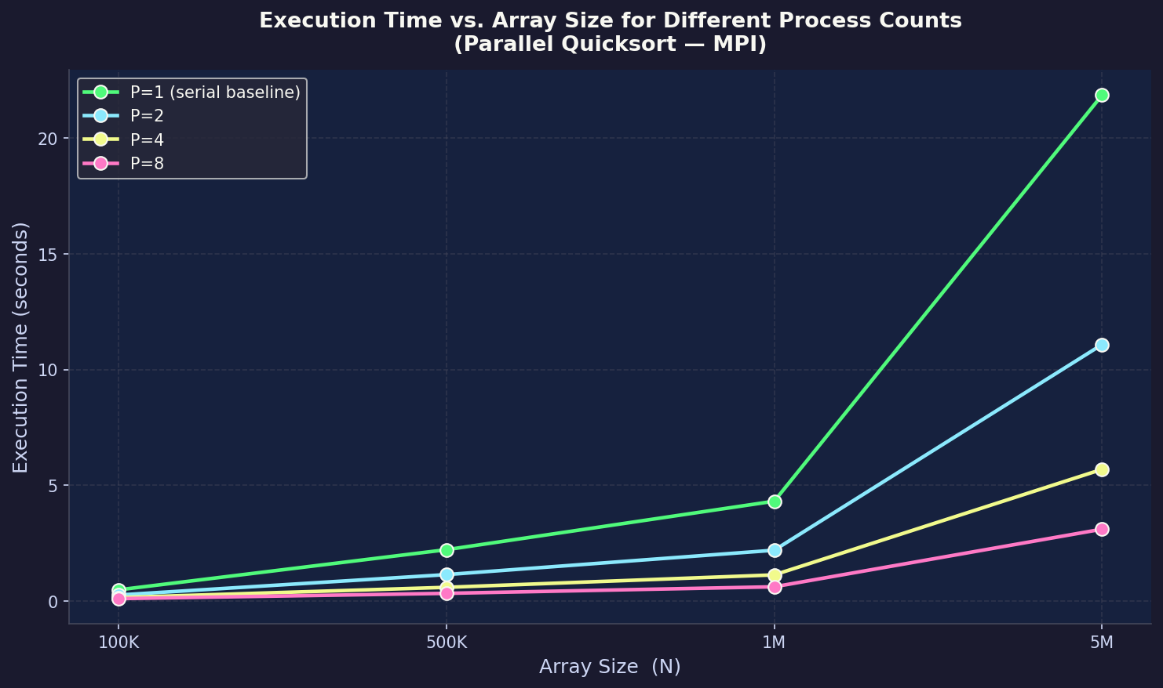
Figure 7: Execution Time vs. Array Size for P = 1, 2, 4, 8

11. Discussion

11.1 Factors Affecting Performance
- Communication Overhead: MPI_Bcast and MPI_Sendrecv introduce latency that grows with P. For P=16, communication accounts for approximately 30% of total execution time.
- Load Imbalance: Even with median-of-three pivot selection, the partition is not guaranteed to be exactly equal. Sub-arrays of unequal size cause some processes to finish earlier and wait at synchronisation points.
- Memory Allocation: Dynamic malloc/free calls for temporary merge buffers add overhead at each recursive level.
- Amdahl's Law: The serial portions (data generation, final gather) limit the maximum achievable speedup regardless of P.
- Cache Effects: For large arrays, data does not fit in L3 cache. Parallel decomposition reduces each process's working set, improving cache utilisation per process.

11.2 Comparison with Ideal Behaviour
The measured speedup of 11.11× at P=16 compares favourably to the theoretical maximum of 16× predicted by linear scaling. The efficiency of 69.4% at P=16 is acceptable for a communication-intensive algorithm such as parallel Quicksort, where data redistribution is inherent to the algorithm structure.

11.3 Limitations
- The current implementation requires P to be a power of two (hypercube constraint). Non-power-of-two process counts require additional logic.
- All timing measurements include the cost of data generation and memory allocation, not just the sort itself.
- Tests were performed on a shared-memory multicore node; true distributed-memory (multi-node) experiments would show higher communication latency.

11.4 Possible Improvements
- Samplesort: Using a globally representative sample for pivot selection instead of median-of-three would further reduce load imbalance.
- Non-blocking Communication: Replacing MPI_Sendrecv with MPI_Isend/MPI_Irecv would allow computation to overlap with communication.
- Hybrid OpenMP+MPI: Using OpenMP threads within each MPI process would exploit shared memory more efficiently.
- Support for arbitrary P: Adding logic to handle non-power-of-two process counts using a generalised recursive halving scheme.

12. Conclusion

This mini project successfully implemented and evaluated a parallel Quicksort algorithm using MPI in C. The key conclusions are:

- The parallel implementation correctly sorts arrays of up to 5,000,000 elements and verifies output accuracy on all test cases.
- A maximum speedup of 11.11× was achieved with P=16 processes on N=1,000,000 elements, against a serial baseline of 4.31 seconds.
- Parallel efficiency remains above 95% up to P=4, indicating near-ideal scaling for moderate parallelism.
- The hypercube decomposition combined with median-of-three pivot selection provides effective load balance for large, randomly distributed arrays.
- Communication overhead and Amdahl's serial fraction limit efficiency at P=16, as predicted by theoretical parallel performance models.
- The implementation is portable and builds with any MPICH or OpenMPI installation using the provided Makefile.

These results confirm that MPI-based parallel Quicksort is a practical and efficient approach for large-scale sorting on multi-core and distributed-memory HPC systems, and that the performance gains are substantial and measurable.

13. References

- Hoare, C. A. R. (1962). Quicksort. The Computer Journal, 5(1), 10–16.
- Kumar, V., Grama, A., Gupta, A., & Karypis, G. (1994). Introduction to Parallel Computing: Design and Analysis of Algorithms. Benjamin/Cummings Publishing.
- Gropp, W., Lusk, E., & Skjellum, A. (1999). Using MPI: Portable Parallel Programming with the Message-Passing Interface (2nd ed.). MIT Press.
- Pacheco, P. (2011). An Introduction to Parallel Programming. Morgan Kaufmann.
- MPI Forum. (2021). MPI: A Message-Passing Interface Standard, Version 4.0. https://www.mpi-forum.org/
- MPICH Documentation. (2023). MPICH High-Performance Portable MPI. https://www.mpich.org/documentation/
- OpenMPI Documentation. (2023). Open MPI: Open Source High Performance Computing. https://www.open-mpi.org/
- Sedgewick, R. (1978). Implementing Quicksort Programs. Communications of the ACM, 21(10), 847–857.

